Guide to the villain storyline:

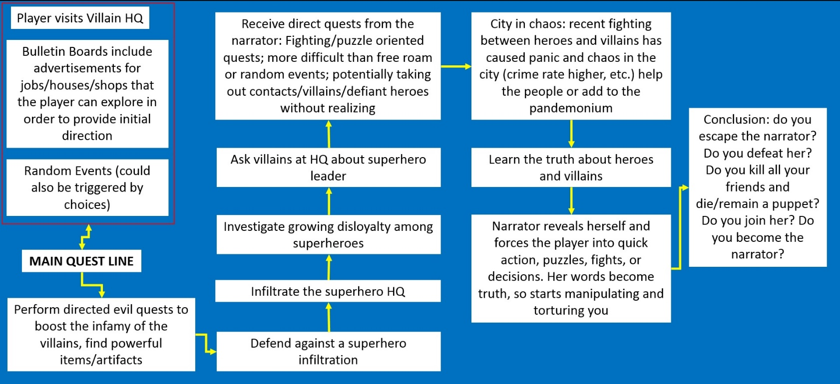NOTICE: This a rough draft. Rough. Roooouuuuuugh.

**Items in the red box:** can be accessed at any point whenever, wherever, indefinitely. Bulletin boards may show advertisements for the houses the player can buy, miscellaneous job requests, shops, or events to provide some sort of direction for the player after leaving the tutorial

**Examples of early directed quests:** a local hero is impeding on your turf, go and teach him a lesson. A bar is refusing to pay taxes to the villains, go get the money. A group of convicts has escaped the prison, go recruit them. A powerful armor is known to be held in blah location, go get it. Etcetera.

**Superhero Infiltration:** is an item stolen? Is somebody hurt or killed or arrested? Maybe this ends differently depending on the player’s actions.

**Infiltrate the superhero HQ:** first time the player witnesses the superhero leader, who is actually the narrator

**Disloyalty among superheroes:** with such a questionable leader, disloyalty is bound to happen. The player could notice this when infiltrating HQ, the buzz around town, through events, etc.

**Asking about SH leader:** could occur directly (the player wants to ask about the leader and starts a conversation) or indirectly (in another conversation or assignment, the topic comes up)

**Narrator’s quests:** I’m thinking here the narrator is starting to get paranoid that her identity will be revealed. In an effort to regain control, she starts giving the player quests directly. Why would the player want to do these quests? Well, instead of a clear good or evil connotation as in the villains/heroes’ quests, these could be neutral quests in which player choice becomes more important. Rewards. Experience. Obedience. For example, some dude has something cool that you’d want, no matter which side you’re on, but how you get it depends on your good vs. evil. Alternatively, there could be scripted events, like the player falling into the sewers and the narrator “helping” guide the player out.

**Chaos:** I imagine a lot of events with a chance for the player to behave various ways. Death, destruction, you get the picture.

**Learn the truth:** find out that the superhero leader is manipulating the superheroes for evil purposes, and that the villains are actually kind of like the good guys. The superheroes aren’t to blame, and many began to distrust the leader, but they are inherently trusting and optimistic and were deceived. Do you punish the superheroes? Do you forgive them?

**Narrator reveals herself:** after learning that the superhero leader is actually evil, the player discovers her true identity *collective gasp* and she tries to kill you

**Conclusion:** The most open ended part, many choices?